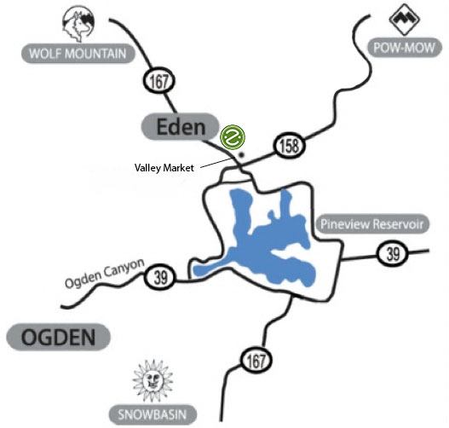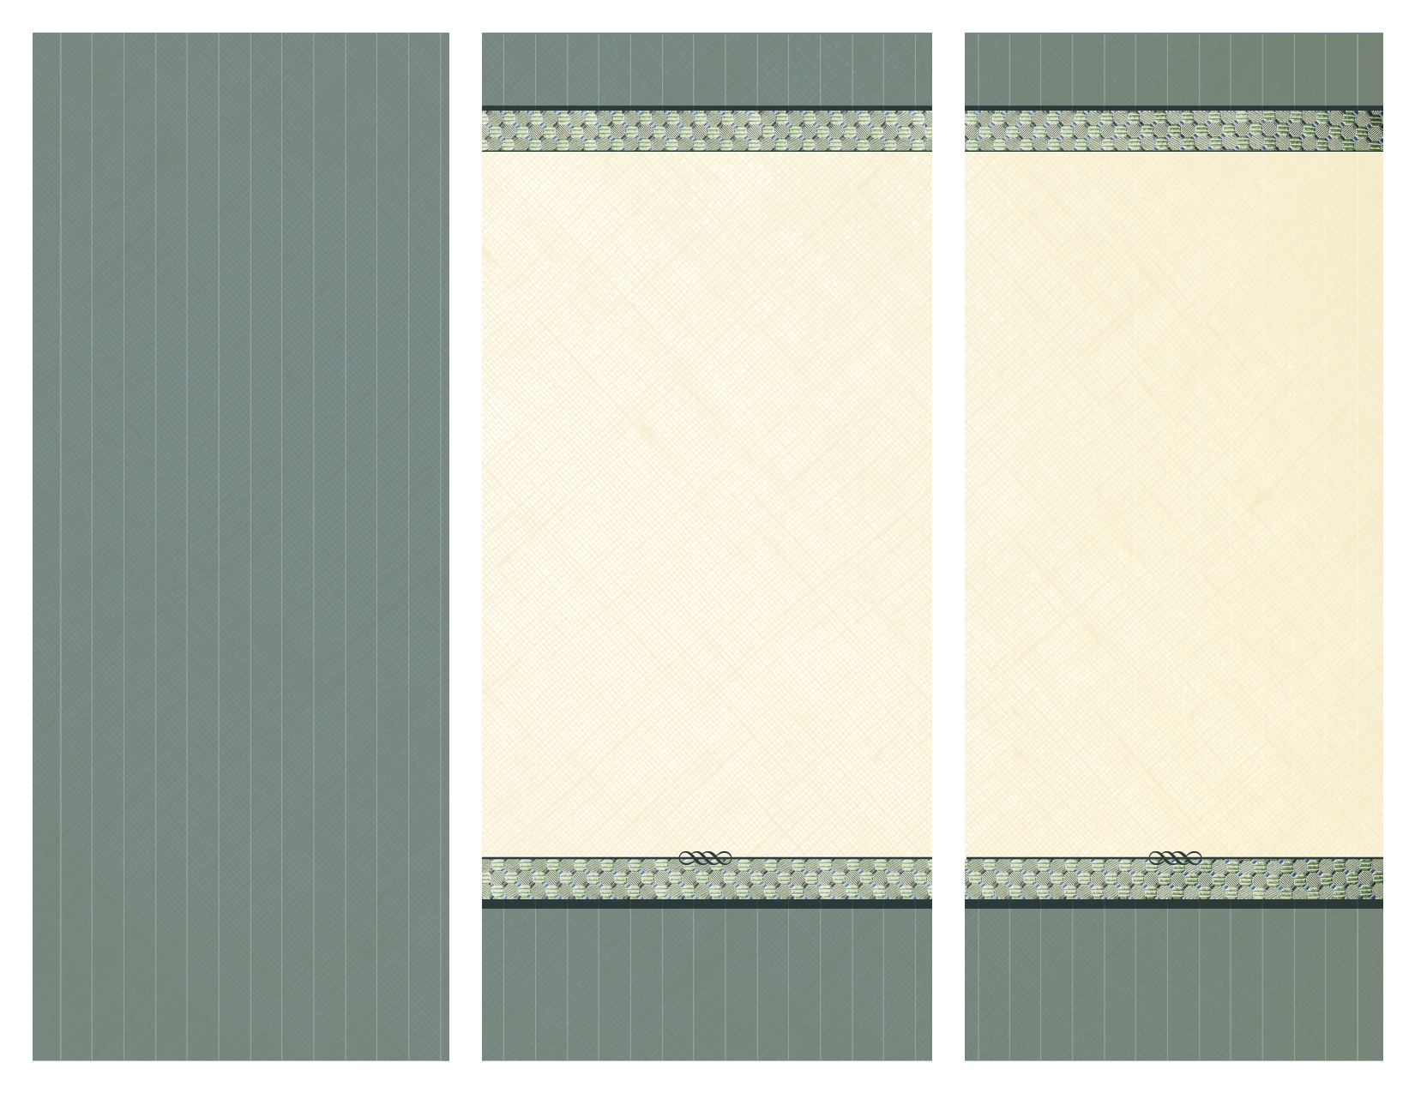7

**801-745-1100**

**801-745-1100**

In-Office Dental Plan

An Insurance Alternative

**2640 North Highway 162**

**Eden,** **Utah 84310**

**Chad L. Wagstaff, DDS**

“Changing Lives…One Smile At A Time.”

**Call 801-745-1100**

**Text 801-624-0010 eden@zimbidental.com**

**2640 North Highway 162**

**Eden, Utah 84310**

*www.zimbidental.coml.com*

Giving You More

Reasons To Smile!

**www.zimbidental.coml.com**

-2 Periodic exams per member per year ($80 value)

-2 Four bitewing series and 2 periapical x-rays per year ($200 value)

- 2 Adult or Child cleanings per year (prophylaxis only not advanced hygiene services such as periodontal maintenance, scaling and root planning, or full mouth debridement, all of which will be offered at the plan discount) ($144 value)

-2 Fluoride treatments ($66 value)

-Members will receive a **significant discount** on all dental work, **up to 30%**.

-**A total value of over $490!**

**Eligibility**

An Insurance Alternative

**Our Mission Statement**

At Zimbi Dental we are committed to providing affordable and efficient dental care while exceeding customer expectations in quality and comfort. With our dedicated and friendly team our patients will leave feeling excited to share their experience with a friend.

In an effort to serve our community better, we have developed an **In-Office Dental Plan**; an insurance alternativefor businesses, families, and individuals who desire excellent oral health care but do not have the option or cannot afford to carry dental insurance.

The **In-Office Dental Plan** provides comprehensive preventative care, as well as a significant savings for restorative and cosmetic treatment, without the obstacles of traditional dental insurance, and all at an affordable price.

With our **In-Office Dental Plan** there is:

* No waiting period to be met
* No deductible to be satisfied
* No annual maximum
* No claim forms
* No treatment restrictions

**In-Office Dental Plan**

**Limitations and Exclusions**

**This plan is administered solely by Chad L. Wagstaff, DDS.** Any dental services performed by any other practitioner are not covered under this plan, including treatment recommended by our office such as referrals and consultations. Procedures performed are limited to those procedures which the doctor feels comfortable performing in our office. Dental plan discounts will not apply to procedures performed when associated with an alternate source, i.e. Medical Insurance, Workman’s Comp, General Liability, etc. The In-Office Dental Plan cannot be used in conjunction with any other dental plan or insurance. Plan cannot be combined with any other offers or discounts and is non-transferable.

There are no eligibility restrictions to individual plans. A family is defined as a husband and wife or partnership, along with any dependent children under the age of 26 still living in the household. Participants are eligible upon payment of enrollment fee. No waiting periods apply.

**Services included in membership**

**All member co-payments for treatment provided are due at the time of service**. Interest free payment plans are available to cover cost of treatment for 3, 6, and 12 Months through the Care Credit Program. Patients can apply for this program with our assistance here in the office or online. See office for details. Membership in the plan may be terminated if any plan member misses multiple appointments or for failure to pay membership fees or properly billed work within a timely manner.

-Missed or broken appointments without 24 hour notice will be charged a $50 cancellation fee. The discounts associated with the In-Office Plan are only available through Chad Wagstaff DDS. Yearly enrollment fee is non-refundable and no refunds will be given if the patient chooses not to use their plan.

**Terms and Conditions**

**Enrollment Fees for 12 mo. period**

* **$245 for individuals**
* **$388 for couples**
* **$517 for family of 3**
* **$638 for family of 4**
* **$125 for each additional family member**

**801-745-1100**